### **School of Electronics and Computer Science**

### **University of Southampton**

### 

### **Runway Redeclaration Tool - User Guide**

### **COMP2211 Software Engineering Group Project**

Team 10: Andrew John Evans (aje3g16)

Lyubomir Tsvetanov Hristov (lth1u17)

Suyash Datt Dubey (sdd1n17)

Kemal Yesildagli (ky1g17)

Denis Kovachev (dk1g17)

The screen is divided into 4 logical sections - obstacle specification + controls, views, runway parameters and calculation breakdown:

**Obstacle specification + Controls (Top left quadrant)** - On the left-hand side of the GUI, there are a selection of buttons that can be used to change the model (Airport, Runways, Obstacle specification), as well as importing and exporting airports and exporting the current situation in a human readable format. To the right of these control is the specification of the current obstacle. There are 2 fields that have a default value and can be changed from this section. There are also controls for setting the slope ratio and blast protection.

**Views (Bottom left quadrant)** - this section contains the top-down and side views of the selected runway as well as some functionalities like colourblind mode, export view, runway rotation or changing of airport/runway. On each view, the thresholds are shown, as well as the appropriate distances for the scenario provided (e.g LDA for landing). The redeclared distances are shown and the calculations are broken down into their components. These views update when the threshold selected is changed or the obstacle specification is added/removed.

**Runway parameters (Top right quadrant) -** This section contains two grids showing the original and redeclared distances for the runway parameters (TODA, TORA, ASDA, LDA). Redeclared distances are updated when an obstacle/runway is added, edited or removed.

**Recalculation Breakdown (Bottom right quadrant) -** A textbox showing how the recalculated runway parameters (TODA, TORA, ASDA, LDA) were calculated, showing the components and values used, so one can understand how the system arrived at these values. This aids comparison with the official procedure for redeclaring runways.

**Starting out**

Upon loading the application, the default runway that will be loaded is Heathrow’s 09R. One can import an airport from XML or edit the existing airport to represent the airport you intend to use.

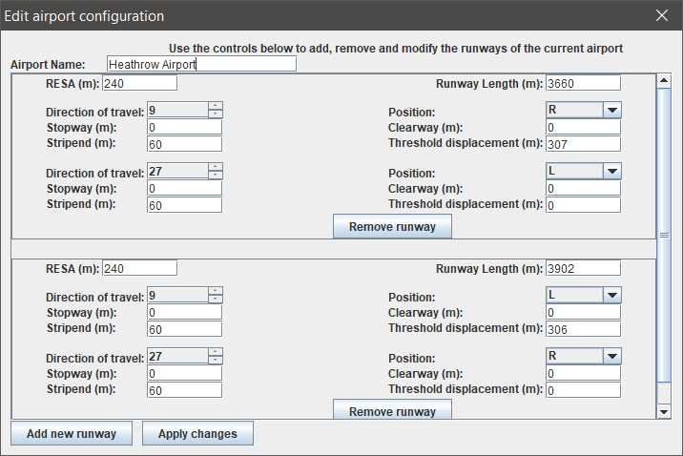

To edit the airport’s runways, click the “**Edit airport**” button on the left of the GUI. Here you can add/edit/remove runways from the airport and change the airport’s name. Each runway has two opposite thresholds, both of which have various parameters that can be configured accordingly.

It is recommended that you save the airport’s you intend to use most frequently as XML on your machine (or such that the files are easily accessible), as to avoid repeatedly input the runway parameters (this may be time consuming). Saving these without an obstacle present will yield the best user experience, and save you time later on. Similarly, saving common obstacles as XML is recommended.

Obstacles can then be added, edited and removed using the “**Add obstacle**”, “**Edit obstacle**”, “**Remove obstacle**” buttons, that’ll create an appropriate dialog to perform those actions.

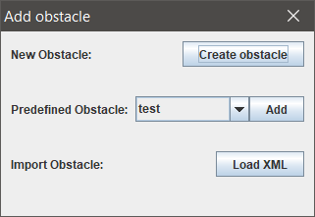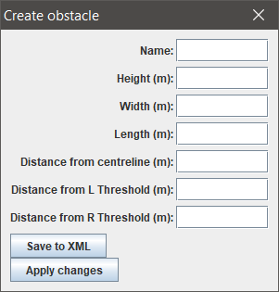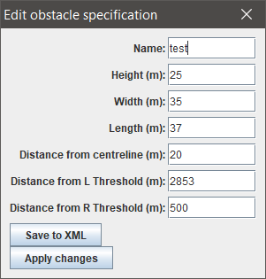

Note, only a single obstacle can be present on a runway at anytime. Once an obstacle is added, the redeclared distances are shown and the views updated. A variety of predefined obstacles are included in the application that may be useful for some scenarios. The specification of these predefined obstacles may need to be edited, to conform properly to the runway they are added to.

**Definitions**

* **Take-Off Run Available (TORA)** - the length of the runway available for take-off, under normal conditions.
* **Take-Off Distance Available (TODA)** - the length of the runway (TORA) + any clearway. This is the total distance an aircraft can safely utilise for its take-off.
* **Accelerate-Stop Distance Available (ASDA)** - the length of the runway (TORA) + any stopway. Used in case of an aborted take-off.
* **Landing Distance Available (LDA)** - the length of the runway available for landing. Starts at the threshold and may displaced by an obstacle or permanently.
* **Runway End Safety Area (RESA)** - An area at each end of the runway intended to reduce the risk of damage to an aircraft by overrunning/undershooting the runway.

**Known Issues**

* Currently, one can only remove one runway at a time whilst editing an airport. Once you’ve removed an airport, you need to save the changes and edit the airport again to add or edit the runways.
* Removing an obstacle doesn’t remove the obstacle from both associated thresholds of a runway strip, and obstacles will reappear after removal.
* Editing a runway doesn’t currently remove the obstacle from the runway as expected (may need to reconfigure the obstacles parameters).

**FAQs**

* What are the system requirements?
  + Java 8 or higher
  + RAM: 128 MB
  + Disk space: 512MB
  + Processor: Minimum Pentium 2 266 MHz processor
  + OS: Windows Vista or later, OSX 10.8.3+, 64-bit Linux
  + Monitor w/ 1024 x 768 resolution or greater
  + Mouse w/ scroll wheel
  + Requirements based on Java 8 requirements
* What do the distance from L threshold/R threshold mean in the obstacle specification?
  + These refer to the distances from the leftmost threshold in the visualisation when not rotated. For example, if the runway selected is 09R/27L, the distance from L threshold refers to the distance of the obstacle from the 09R threshold.
  + Alternatively, L Threshold is the lower of the two thresholds, as that is always shown on the left (when not rotated).
* What effect do the length, width and distance from centerline parameters have on the calculations?
  + These parameters do not affect the calculations or visualisations as of yet. These parameters were included for completeness and may be used in future extensions to the application (if deemed necessary/useful).
* Distances/dimensions should be assumed to be in metres, unless stated otherwise.
* What images formats does “Export View” support?
  + PNG
  + GIF
  + JPEG
  + BMP
* Where’s the obstacle on the side view?
  + The obstacle in side view is the highest line marked with the label “Obstacle”.
* What do the abbreviations on the side view mean?
  + **DRTH/DLTH -** Distance from right/left threshold
  + **S.E** - Strip end